Supervision 2

2. Memory Management

  - True. They require a timer
  - False. A context switch also requires storing the state of the registers and other process state information.
  - True. The process can use the I/O device asynchronously
  - False. If “optimal” means minimal waiting time, then SRTF is better.
  - True. Later processes are held up behind long-running early processes.
  - True. Segments are variable size but tend to be bigger than pages.
  - True. DMA prevents livelock, which is whem so many interrupts occur that the processor can’t do any meaningful work with the data before being interrupted.
  - False. System calls are essential in modern operating systems because they allow the kernel to perform privileged actions on the user’s behalf. This enables processes to perform actions which they would otherwise not have been able to perform safely.
  - True. You can’t create a hard link without knowledge of the filesystem on which the inode exists.
  - False. You can only redirect to files

  - To prevent crashing, interrupts are required. To prevent locking up the system, a timer for preemptive scheduling is required. To prevent interfering with other applications, virtual memory (e.g. paging) is required.
  - They raise a system call interrupt.
  - We could try to implement these features in software, which would be much slower and more prone to attacks.

  - External fragmentation is caused by dynamic partitioning of memory. It is when the partitions allocated to each process have small gaps in between, which are too small to be allocated to another process. It can be handled by using compaction, but this requires run-time reallocation of partitions. It can also be handled using fixed-size partitions such as with paging.
Internal fragmentation is when a process does not use all of the memory allocated to it. This occurs in fixed-size partitions such as with paging. It can be handled by using smaller pages or with dynamic partitioning.
  - A process’ page table contains a mapping from page numbers to the associated frame numbers in main memory. The TLB contains a cache of the frame numbers read from the page table. If a page number is to be looked up, the processor first checks whether it is cached in the TLB, and if not, look it up in the page table and cache the result in the TLB.
  - The base register contains the base address of the level 1 page table. The first section of the virtual address is the page number for the level 1 page table. Stored there is the base address of the associated level 2 page table. The second section of the virtual address is the page number for that level 2 page table. Here the associated PTE is stored.
This is to prevent us having to store large page tables in memory all at once.
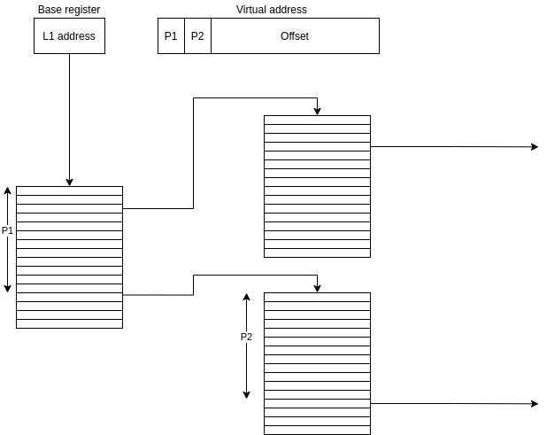

3. File Systems & IO
- A

- In blocking mode, the application halts until some event (e.g. a keypress) occurs at which point execution continues
In non-blocking mode, the application “polls” the device (e.g. “Is the A key pressed?”) and the device responds immediately (e.g. “Yes” or “No”). The application then continues executing immediately.
In asynchronous mode, the application specifies a callback point to which execution will jump once an event (e.g. a keypress) has occurred, but the process can still run in the meantime.

  - To translate a file “name” to the location of the file on the disk, and to reflect the organisational structure of the files.
  - 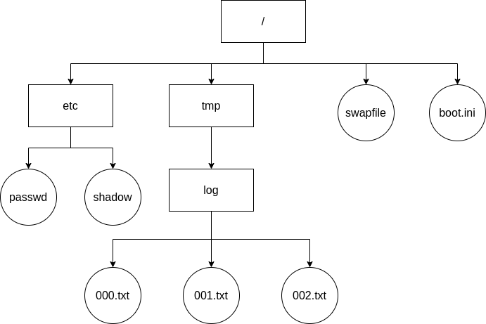
Directories are “parent” of other directories/files creating a tree-like hierarchy. However soft links can connect two nodes together, making it more like a web structure.
  - Location of file on disk
Size of file
File type
Permissions (e.g. read/write/execute for different users)
Timestamp created & last modified
Owner
  - A hard link is a relationship between a file name and a inode. A hard link cannot span a mount point (i.e. the metadata must be in the same filesystem as the inode)
  - A soft link is a file which contains the name of another file, telling the user where to find the data. There are no restrictions on the location of the file metadata for a symlink.

  - See 3.3
  - Caching IO reads and writes
Scheduling IO requests
Buffering (including double/circular buffering)
DMA
2009p2q3

  - The processor can ensure that a process can’t interfere with another process’ memory
The process does not need to be aware of which sections of memory it is allowed to access
If main memory is getting full, the processor can map a certain region of the virtual address space to the disk without the process needing to change its intructions.
  - See 2.6.a
2015p2q4
- A page fault is when a virtual address corresponds to an invalid/forbidden section of memory for that process, or if the page is non-resident and needs to be “paged in”
- A segment fault occurs when the virtual address is invalid (the segment number is greater than the length of the segment table, or the offset is greater than the length of the segment). If there is a stack segment fault the process should terminate.

- Thrashing is when there are so many processes that they end up stealing frames from each other, but those frames are needed again and so many faults occur, reducing the useful CPU time. It can be avoided by reducing the degree of multiprogramming.
- With a page fault, page replacement needs to occur. This means that the CPU needs to predict which resident frame is likely to be unused for the longest time in order to reduce the number of future page faults, which is non-trivial.

